Memo

|  |  |
| --- | --- |
| To: | Dr. Derek Ross |
| From: | Troy Dabney |
| Date: | October 18, 2013 |
| Re: | Project 2: Advertisement Design Memo for Dogfighting |
|  |  |

**Objective:**

The objective of this memo is to explain the importance of my advertisement and to support my motives as a designer. In this memo, I will describe the design I created, defend the design choices I made during the creation process, and explain the testing process that was carried out before the advertisement was finalized.

**Context:**

Dogfighting is defined by The Humane Society of the United States (The HSUS) as “a sadistic ‘contest’ in which two dogs—specifically bred, conditioned, and trained to fight—are placed in a pit (generally a small arena enclosed by plywood walls) to fight each other for the spectators' entertainment and gambling” (Sisneros—Dogfighting Fact Sheet). On the surface, dogfighting can seem to only affect the two dogs who are fighting and their owners; however, the effects of this activity reach much further than what one may initially perceive.

Puppy mills are common factory-like breeding grounds for future canine fighters; an unaccounted number of pets are abducted each year to be used as bait dogs with which fighter dogs practice on; children become desensitized to violence; and other illegal activities such as gambling, gang related activities, drug distribution, are often associated with dogfighting. It goes without saying that the sport supports animal cruelty. Medical attention is not sought for any of the dogs and many die from injuries sustained from the fight. Losers as well as dogs who do not seem to have an innate urge to fight are executed using “do it yourself” methods ranging from plugging (electrocution) to euthanasia (using illegally obtained medications) as many involved in the sport do not see them being suitable for any other purpose other than fighting.

Although stricter punishments for those involved in dogfighting as well as media attention—the widespread attention given to the Michael Vick dogfighting case and, more recently, the interstate ring that was shutdown in August 2013, for example—have been effective tools in ending dogfighting, dogfighting continues to be a prevalent issue in the United States.

**Audience:**

Since my design is an 11” x 17” poster, I feel that its size can contribute to the advertisement being placed in both indoor and outdoor areas. Partially because of this, I expect my audience to consist of a wide variety of people.

The demographic of my audience will be dependent on where the advertisement is placed. I feel that my design encourages the advertisement to be suitable for schools, businesses, and organizations in areas both plagued by participants in this activity as well as people who are eager and able to help fight for the cause of putting an end to dogfighting.

**Purpose:**

When issues are driven by secrecy, which is the case with dogfighting, an even larger issue is created when people are ignorant of the fact that the issue is a problem that is present in the community. Without knowing that something is problem, how can resolution efforts begin? The purpose of my advertisement is to draw attention to dogfighting in order to encourage more people to take interest in the cause. With my design, I hope to facilitate change that will contribute to the eradication of the blood sport as well as the exploitation of fighting dogs completely.

Currently, The HSUS offers a reward of up to $5,000 to contributors of information that leads to the arrest and conviction of anyone involved in dogfighting; they also provide free posters and other advertising materials that anyone can download or order in order to promote the reward (Taking Action to Stop Dogfighting). Consider Figure 1.

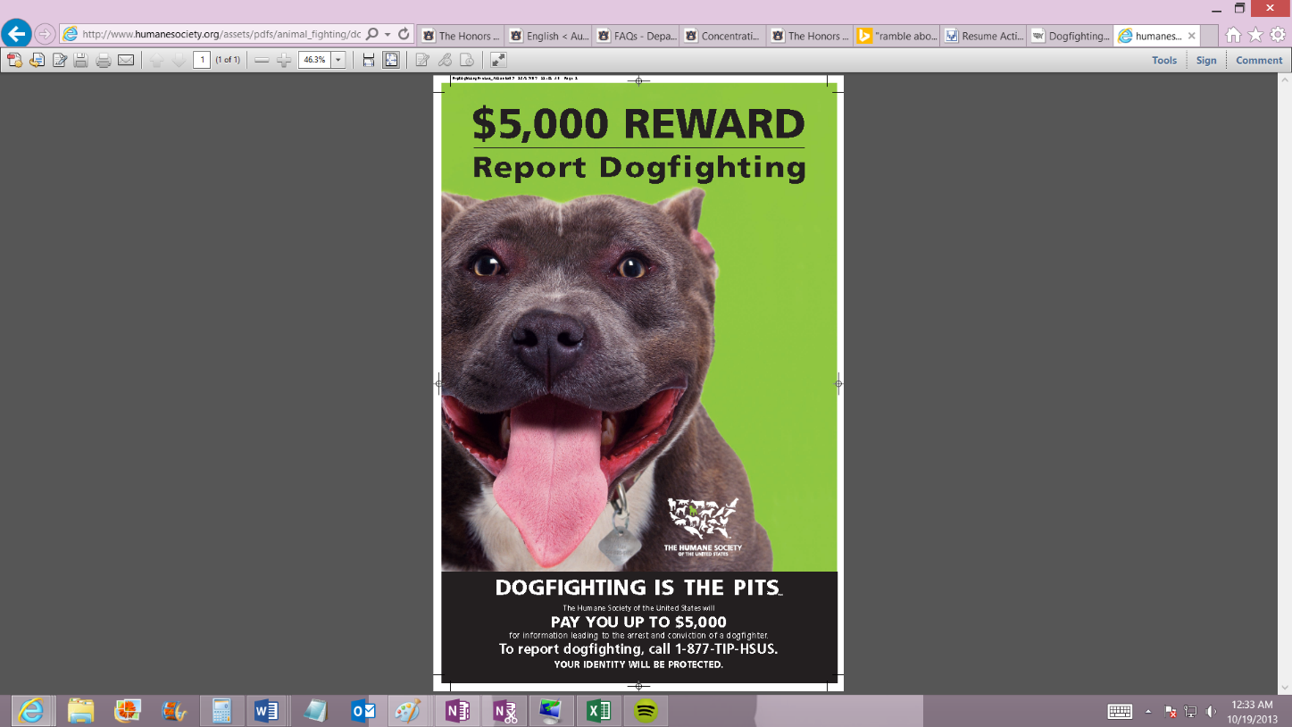The HSUS’s poster consists of a smiling pit bull with a bright green background behind him along with “$5,000 REWARD” bolded at the top of the poster. I feel that this would effectively attract people’s attention and encourage them to want to report dogfighting in order to earn the reward (Sisneros-_Dogfighting Fact Sheet). Since my primary goal is awareness, I chose to take a different approach by creating an advertisement that highlights the fighting aspect of dogfighting without using a realistic image of dogfighting.

**Figure 1:** A poster from The HSUS designed to encourage people to report dogfighting.

The motivation behind my rhetorical appeals will be discussed in three sections: *pathos, logos, and ethos.*

*Pathos*

My advertisement appeals to users’ emotions by inviting them to consider what dogs experience when they are put against each other. This move is strategic in that the two dogs I use are not actively fighting. Although I do not portray the actual act of dogfighting, I attempt to evoke emotional responses in my views when they realize that dogs are not afforded the same protections that boxers are during matches. Donald A. Norman writes in “Emotional Design” that reflective design is “about the meaning of a product,” and in my design I implement reflective design by keeping the cause in mind during the design process but I also rely on pathos to facilitate reflection of the design’s message (Norman 83). After their realizations, I want the underlying messages that the juxtaposition of dogfighting and boxing elicits to resonate with my viewers: boxers have choice and protection whereas dogs do not.

*Ethos*

Ethos, or how a user perceives the character of a speaker (or in this case, a designer), is present in my ad (Kimball & Hawkins, 65). As the designer of this anti-dogfighting advertisement, I want viewers to consider me to be a person who is against the injustices that stem from dogfighting. I also want my advertisement’s viewers to see me as a person who can be trusted to adhere to the solemnity of the matter through my design.

I chose to incorporate boxing into my design because of the connotations linked to the sport. Boxing is a serious sport in which two people intentionally cause bodily harm to their opponent and it is not traditionally considered a family-oriented sport because of its combativeness. I relied on the seriousness associated with boxing to communicate to my reader that I feel that dogfighting is a serious issue that needs to be discussed and resolved. Also, I hope that the phrase and color choices I made regarding my message accurately convey my negative feelings towards dogfighting and my passion and enthusiasm for making my audience aware of the exigency.

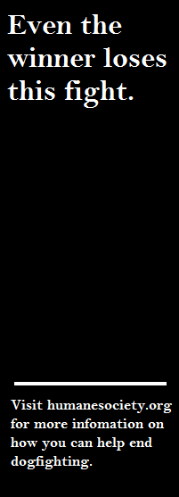Although I mention The HSUS, I also do not use The HSUS’s logo in my design since it is a registered trademark. Instead, I include a link to the organization’s website and I also include a disclaimer stating that The HSUS has not officially endorsed this advertisement. I felt that this was necessary legally and ethically because I did not want to mislead my readers into thinking that I has secured endorsement from the organization when I have not.

*Logos*

Since my advertisement relies strongly on visual imagery, implications by its viewers, and emotional engagement, the text that I have included on the right of my design serves as its primary logical points. Consider Figure 2. “Even the winner loses this fight,” appears in the top-right corner of my advertisement.

One could argue that technically the winner leaves the ring a victor, but my design suggests the dogs involved in dogfights cannot be winners. Fight speculators who have placed bets on the dogs may win monetary prizes and the dogs’ owners may gain reputation, but the truth is that the dogs gain nothing substantial when they win fights. Eventually, death is the primary way out of the fighting world for these dogs.

One could also argue that they gain another day to live, but this would be a moot argument in terms of entitlement to things such as a humane life. This unveils another motive of my advertisement: to encourage conversation about acquiring basic rights to animals.

**Figure 2:** Text from the right portion of my advertisement.

**Design Choices:**

*Format*

Before I began the actual creation of my design, I considered what format would be most appropriate for my goal. Although I think that a billboard would be a very useful medium that could be used to reach a large audience, it is not cost effective and the production would not be feasible for this project. Instead, I decided that an 11” x 17” poster would be large enough to reach a vast audience, easy to place indoors and outdoors, and manageable enough for a user to hold it or view it hanging on a wall while still receiving the message.

*Color*

Instead of choosing bold colors to include in my design, which is what I believe The HSUS chose to do to emphasize their $5,000 reward on their anti-dogfighting posters, I opted to use grayscale imagery to convey my message. I felt that using color could possibly hinder the serious tone that I wanted to convey. Also, I felt that using grayscale in my design would not highlight my novice Photoshop skills and, in turn, cause my viewers to think less of me as a designer and not take my cause to heart.

*Orientation*

The orientation of my design also had to be taken into consideration. I chose to create an advertisement that was 11” x 17”, but I also chose to utilize a landscape orientation instead of a portrait orientation. My text is on the far right of my advertisement, and I elected to create a landscape design because I wanted my viewers to consider the picture and emotionally respond to it before reading the text.

*Contrast and Value*

Lastly, I used contrast and value to emphasize the text that appeared on my advertisement. Since the primary image on my advertisement is in grayscale, I chose to highlight my text by adding contrast by placing white text on a wide, black box that expands height-wise across the page. Value highlights the white text and the black box against the gray picture of the photoshopped dog boxers to emphasize the content of the text.

**Testing Process:**

*Research*

In order to test the effectiveness of my design, I considered my own personal experience with injustices regarding animal treatment. As someone who lived with an animal abuser, I tried to think of a creative and effective design that would influence my viewers to take interest in the cause. It did not take me very long to realize that although I knew I did not support dogfighting, I was against something I had never seen. Since watching a live dogfight was completely out of the question, I began searching for documentaries that had been created about dogfighting. I watched two documentaries on dogfighting: “Dog Fights” and “Out of the Pit: Dog Fighting in Chicago” to gain more factual/fact-based understanding of the sport (“Pitbull Fighting Documentary” and “Out of the Pit”).

*Testing*

After brainstorming, I created a draft of my design and shared it with my classmates, family, and friends. Initially, my classmates responded when they saw me working on the design in class and when we discussed our individual designs. When my first draft of my design was complete, I conducted usability testing by asking users to respond to the design based on Jakob Nielsen’s five variables of usability (Kimball and Hawkins, 66). I focused on three of the five variables of usability—efficiency, memorability, and subjective satisfaction—and I used their responses to gage how effective my design was in these terms. I wanted to ensure that my design was creatively direct, rhetorically impacting, and well-received by users.

I took their responses into consideration as I finalized my next draft, and I presented this draft to my class in order to obtain feedback for my final production. My last step in the testing process involved evaluating the final design myself to ensure that the design was appropriate for my audience, successfully relayed my message, and achieved my goal for the design.

**References:**

Kimball, M. A., & Hawkins, A. R. (2008). Document design: a guide for technical communicators. Boston/New York: Bedford/St. Martin’s.

Norman, D. A. (2004). Emotional design. New York: Basic Books.

Out of the pit: Dog fighting in Chicago [Video file]. Retrieved from http://www.youtube.com/watch?v=UozSY6TNgKo

Pitbull fighting documentary [Video file]. Retrieved from http://www.youtube.com/watch?v=oauWfQLxrYk&feature=youtu.be

Sisneros, C. (2009). Dogfighting fact sheet. *The humane society of the United States: Fact sheets.* Retrieved from http://www.humanesociety.org/issues/dogfighting/facts/dogfighting_fact_sheet.html

Taking action to stop dogfighting. (2013). *The humane society of the United States.* Retrieved from http://www.humanesociety.org/issues/dogfighting/tips/dogfighting_action.html